Changing The SSH Port
Filed under: Technical Support
While there are many ways to make sure your server is as secure as possible there are some basic steps and measures that you can take to cover your bases.
Users with a Linux server can change their SSH port to something other than the default port (22).
Step #1: Reconfigure SSHD
The easiest way to change the port is to SSH into the server as root:
ssh root@hostname/IP
(hostname/IP should be replaced with the hostname of your server or the main IP address of your server)
Once you are logged in to the server as root we can begin editing the sshd_config file. As with any modification to an important server file, it is always a good idea to back it up before making any changes:
cp /etc/ssh/sshd_config /etc/ssh/sshd_config_backup
Now we are ready to modify the file. Open /etc/ssh/sshd_config in your favorite text editor (for this example we will use Vim) and locate the line that specifies the port. If your sshd_config file has not been altered the Port setting will be commented out with a # symbol (example below).
vim /etc/ssh/sshd_config
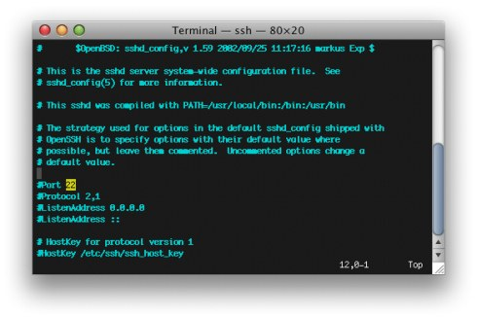
The # symbol tells the server to ignore anything after it on the same line, so we will need to remove that character and then change the number 22 to something else. Be sure you do not pick a port number that is in use by a different service. If you are unsure, Wikipedia has a list of port numbers and their uses. Try to use a port number that is not listed. For this example, we will use Port 2222 (which is used by Windows servers but not by default on Linux servers).
Remove the # symbol and change the port number:
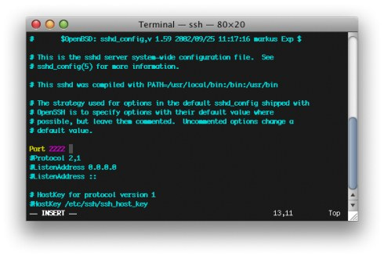
Save your changes and close the sshd_config file.
We will also need to open the new port in the server’s firewall. This tutorial describes firewall changes on a standalone dedicated or virtual private server. If you have a hardware firewall in place please open a ticket with our support department so that we can make the necessary changes.
Step #2: Updating Your Firewall
Once again we will use Vim as our text editor to make changes to the APF firewall configuration. As with the SSH configuration file it is a good idea to create a backup prior to making any changes.
cp /etc/apf/conf.apf /etc/apf/conf.apf.bak
Open /etc/apf/conf.apf in Vim (or your favorite text editor) and locate the line labeled Common ingress (inbound) TCP ports.
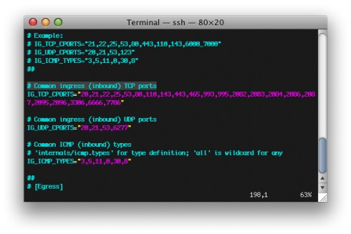
Add your new port number to the list of existing ingress ports. Be sure to add commas where necessary (follow the format of the existing port numbers).
Save your changes to the conf.apf file and close your text editor.
Step #3: Restart Services
SSH and APF must now be restarted in order to activate your changes. You can do so by running the command ‘/etc/init.d/apf restart’ followed by ‘/etc/init.d/sshd restart’ (example below):
service sshd restart
service apf restart
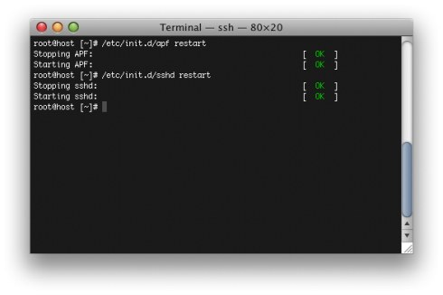
SSH will restart and listen on the port number you have specified.
It is important to note that if you change SSH’s port number this will also alter the way you need to run certain commands that utilize SSH. Examples of commands that would need the new port number specified include scp andrsync.
In order to give you the best support (and often fix problems before you even know they are happening) we need to have your SSH port on file in our records for your account. Log in to your Liquid Web Manage account athttps://manage.liquidweb.com/ and follow our tutorial on Updating Your Root User and SSH Information in Manage

If file system is full?

I ran across an uncommon scenario whereby a file system on a Linux server was showing it was nearly full, but I could only account for about half of the space usage.
[root@web18 /]# df -h /
Filesystem Size Used Avail Use% Mounted on
/dev/sda2 165G 135G 21G 87% /
After some research, it was determined that a stray process had a lock in place on files that were previously deleted. Since this lock was in place, the file system would not show the space as available.
[root@web18 /]# ls -l /proc/*/fd/* | grep deleted
l-wx------ 1 nginx nginx 64 Aug 1 09:39 /proc/55627/fd/15 ->
/var/log/nginx/access_log-20130731 (deleted)
l-wx------ 1 nginx nginx 64 Aug 1 09:39 /proc/55627/fd/16 ->
/var/log/nginx/error_log-20130731 (deleted)
After killing the stale nginx process (killall -9 nginx), the space started showing its normal consumption.
[root@web18 /]# df -h /
Filesystem Size Used Avail Use% Mounted on
/dev/sda2 165G 67G 90G 43% /
I hope this helps someone who suffers from a similar problem
DMESG
The dmesg command is used to write the kernel messages in Linux and other Unix-like operating systems to standard output (which by default is the display screen).
A kernel is the core of an operating system. It is the first part of the operating system that is loaded into memory when a computer boots up (i.e., starts up), and it controls virtually everything on a system. The numerous messages generated by the kernel that appear on the display screen as a computer boots up show the hardware devices that the kernel detects and indicate whether it is able to configure them.
dmesg obtains its data by reading the kernel ring buffer. A buffer is a portion of a computer's memory that is set aside as a temporary holding place for data that is being sent to or received from an external device, such as a hard disk drive (HDD), printer or keyboard. A ring buffer is a buffer of fixed size for which any new data added to it overwrites the oldest data in it.
dmesg can be very useful when troubleshooting or just trying to obtain information about the hardware on a system. Its basic syntax is
dmesg [options]
Invoking dmesg without any of its options (which are rarely used) causes it to write all the kernel messages to standard output. This usually produces far too many lines to fit into the display screen all at once, and thus only the final messages are visible. However, the output can be redirected to the lesscommand through the use of a pipe (designated by the vertical bar character), thereby allowing the startup messages to be viewed one screenful at a time:
dmesg | less
less allows the output to be moved forward one screenful at a time by pressing the SPACE bar, backward by pressing the b key and removed by pressing the q key. (The more command could have been used here instead of the less command; however, less is newer than more and has additional functions, including the ability to return to previous pages of the output.)
When a user encounters a problem with the system, it can be convenient to write the output of dmesg to a file and then send that file by e-mail to a system administrator or other knowledgeable person for assistance. For example, the output could be redirected to a file named boot_messages using the output redirection operator (designated by a rightward facing angle bracket) as follows:
dmesg > boot_messages
Because of the length of the output of dmesg, it can be convenient to pipe its output to grep, a filter which searches for any lines that contain the string(i.e., sequence of characters) following it. The -i option can be used to tell grep to ignore the case (i.e., lower case or upper case) of the letters in the string. For example, the following command lists all references to USB (universal serial bus) devices in the kernel messages:
dmesg | grep -i usb
And the following tells dmesg to show all serial ports (which are represented by the string tty):
dmesg | grep -i tty
The dmesg and grep combination can also be used to show how much physical memory (i.e., RAM) is available on the system:
dmesg | grep -i memory
The following command checks to confirm that the HDD(s) is running in DMA (direct memory access) mode:
dmesg | grep -i dma
The output of dmesg is maintained in the log file /var/log/dmesg, and it can thus also be easily viewed by reading that file with a text editor, such as vi orgedit, or with a command such as cat, e.g.,
cat /var/log/dmesg | less
dmesg (Display message or driver message) is a command which will show Kernel ring buffers. These messages contain valuable information about device drivers loaded into the kernel at the time of booting as well as when we connect a hardware to the system on the fly. In other words dmesg will give us details about hardware drivers connected to, disconnected from a machine and any errors when hardware driver is loaded into the kernel. These messages are helpful in diagnosing or debugging hardware and device driver issues. Already covered command in the series is
Get BIOS, Firmware, Hardware And Drivers Details in Linux/Unix

dmesg command syntax
dmesg options

dmesg output format
[ time ] device name: message
[ time ] : number seconds from the boot time. If we see something like 34.23445 as time stamp, that indicates this message was created after 34 seconds of booting the machine.
device name: This will give us the hardware device name along with manufacture details.
message: This is actual information we have to look at, this message contain information about devices loaded information, if it's not loaded it will give us error etc.

Learn dmesg with examples
Example 1: Display all the devices drivers loaded in to kernel.
dmesg
The above command will give as all the hardware drivers loaded in to kernel, their status success or failed and even error message why they are failed.
Example2: Display hardware information related to Ethernet port eth0
dmesg | grep -i eth0
Clipped Output:
[ 0.000000] Initializing cgroup subsys cpuset [ 0.000000] Initializing cgroup subsys cpu
[ 0.000000] Linux version 3.5.0-25-generic (buildd@komainu) (gcc version 4.7.2 (Ubuntu/Linaro 4.7.2-2ubuntu1) ) #39-Ubuntu SMP Mon Feb 25 18:26:58 UTC 2013 (Ubuntu 3.5.0-25.39-generic 3.5.7.4)
[ 0.000000] Command line: BOOT_IMAGE=/boot/vmlinuz-3.5.0-25-generic root=UUID=9b1dca12-2bf6-47d3-ab45-929f85bec913 ro quiet splash vt.handoff=7
[ 0.000000] KERNEL supported cpus:
[ 0.000000] Intel GenuineIntel
[ 0.000000] AMD AuthenticAMD
[ 0.000000] Centaur CentaurHauls
[ 0.000000] e820: BIOS-provided physical RAM map:
We can use grep command to filter any kind of information from dmesg command. Know more about grep command here.
To display USB stuff
dmesg | grep -i usb
Output:
[ 0.898683] ACPI: bus type usb registered
[ 0.898700] usbcore: registered new interface driver usbfs
[ 0.898707] usbcore: registered new interface driver hub
[ 0.898725] usbcore: registered new device driver usb
[ 1.057206] ehci_hcd: USB 2.0 'Enhanced' Host Controller (EHCI) Driver
[ 1.057248] ehci_hcd 0000:00:1a.0: new USB bus registered, assigned bus number 1
[ 1.071681] ehci_hcd 0000:00:1a.0: USB 2.0 started, EHCI 1.00
[ 1.071737] usb usb1: New USB device found, idVendor=1d6b, idProduct=0002
[ 1.071742] usb usb1: New USB device strings: Mfr=3, Product=2, SerialNumber=1

To display total memory available and shared memory details
dmesg | grep -i Memory
Output:
[ 0.000000] Memory: 8008776k/9697280k available (6722k kernel code, 1460428k absent, 228076k reserved, 6448k data, 932k init)
[ 0.000000] please try 'cgroup_disable=memory' option if you don't want memory cgroups
[ 0.003319] Initializing cgroup subsys memory
[ 0.497325] Freeing initrd memory: 15664k freed
[ 1.723922] Freeing unused kernel memory: 932k freed
[ 1.727869] Freeing unused kernel memory: 1460k freed
[ 1.730885] Freeing unused kernel memory: 1120k freed
Display if any bluetooth device is present or not
dmesg | grep -i bluetooth
Output:
[ 27.145978] Bluetooth: Core ver 2.16
[ 27.145998] Bluetooth: HCI device and connection manager initialized
[ 27.146001] Bluetooth: HCI socket layer initialized
[ 27.146003] Bluetooth: L2CAP socket layer initialized
[ 27.146009] Bluetooth: SCO socket layer initialized
[ 41.586902] Bluetooth: RFCOMM TTY layer initialized
[ 41.586909] Bluetooth: RFCOMM socket layer initialized
[ 41.586911] Bluetooth: RFCOMM ver 1.11
[ 42.003041] Bluetooth: BNEP (Ethernet Emulation) ver 1.3
[ 42.003045] Bluetooth: BNEP filters: protocol multicast
Display tty information

dmesg | grep -i tty
Output:
[ 0.000000] console [tty0] enabled
[ 34.210105] usb 2-1.1: GSM modem (1-port) converter now attached to ttyUSB0
[ 34.210198] usb 2-1.1: GSM modem (1-port) converter now attached to ttyUSB1
[ 34.210285] usb 2-1.1: GSM modem (1-port) converter now attached to ttyUSB2
[ 41.586902] Bluetooth: RFCOMM TTY layer initialized
[ 197.980023] option1 ttyUSB0: option_instat_callback: error -108

More interaction with dmesg:
We can clear dmesg logs from dmesg command output if required by using clear switch -c as shown below.
dmesg -c
Note: This command will clear dmesg logs from boot time to till that time. If you connect any hardware after this command execution, you can see these new messages in dmesg output.
accidentally deleted dmesg messages by running dmesg -c? Dont worry these messages are stored in /var/log/kern.log or /var/log/dmesg files.
Check latest dmesg logs by viewing content of these two files.
cat /var/log/kern.log
Output:
May 19 06:59:46 linuxnix kernel: [ 3047.124011] atkbd serio0: Unknown key released (translated set 2, code 0xab on isa0060/serio0).
May 19 06:59:46 linuxnix kernel: [ 3047.124015] atkbd serio0: Use 'setkeycodes e02b <keycode>' to make it known.
May 19 06:59:46 linuxnix kernel: [ 3047.382982] atkbd serio0: Unknown key pressed (translated set 2, code 0xab on isa0060/serio0).
May 19 06:59:46 linuxnix kernel: [ 3047.383000] atkbd serio0: Use 'setkeycodes e02b <keycode>' to make it known.
or
cat /var/log/dmesg
Output:
[ 38.115030] RPC: Registered named UNIX socket transport module.
[ 38.115034] RPC: Registered udp transport module.
[ 38.115036] RPC: Registered tcp transport module.
[ 38.115038] RPC: Registered tcp NFSv4.1 backchannel transport module.
[ 38.186630] FS-Cache: Loaded
[ 38.235731] init: munin-node main process (1082) terminated with status 127
[ 38.235754] init: munin-node main process ended, respawning
[ 38.300708] NFS: Registering the id_resolver key type
[ 38.300724] Key type id_resolver registered
[ 38.300725] Key type id_legacy registered
[ 38.300733] FS-Cache: Netfs 'nfs' registered for caching
One advantage about kern.log file is it will give you system time for each log it created instead of boot time. In our next posts we will see how to use other hardware related commands in detail.

Swap

UNIX / Linux: 2 Ways to Add Swap Space Using dd, mkswap and swapon
by RAMESH NATARAJAN on AUGUST 18, 2010
Question: I would like to add more swap space to my Linux system. Can you explain with clear examples on how to increase the swap space?
Answer: You can either use a dedicated hard drive partition to add new swap space, or create a swap file on an existing filesystem and use it as swap space.

How much swap space is currently used by the system?
Free command displays the swap space. free -k shows the output in KB.
# free -k
total used free shared buffers cached
Mem: 3082356 2043700 1038656 0 50976 1646268
-/+ buffers/cache: 346456 2735900
Swap: 4192956 0 4192956
Swapon command with option -s, displays the current swap space in KB.
# swapon -s
Filename Type Size Used Priority
/dev/sda2 partition 4192956 0 -1
Swapon -s, is same as the following.
# cat /proc/swaps
Filename Type Size Used Priority
/dev/sda2 partition 4192956 0 -1

Method 1: Use a Hard Drive Partition for Additional Swap Space
If you have an additional hard disk, (or space available in an existing disk), create a partition using fdisk command. Let us assume that this partition is called /dev/sdc1
Now setup this newly created partition as swap area using the mkswap command as shown below.
# mkswap /dev/sdc1
Enable the swap partition for usage using swapon command as shown below.
# swapon /dev/sdc1
To make this swap space partition available even after the reboot, add the following line to the /etc/fstab file.
# cat /etc/fstab
/dev/sdc1 swap swap defaults 0 0
Verify whether the newly created swap area is available for your use.
# swapon -s
Filename Type Size Used Priority
/dev/sda2 partition 4192956 0 -1
/dev/sdc1 partition 1048568 0 -2

# free -k
total used free shared buffers cached
Mem: 3082356 3022364 59992 0 52056 2646472
-/+ buffers/cache: 323836 2758520
Swap: 5241524 0 5241524
Note: In the output of swapon -s command, the Type column will say “partition” if the swap space is created from a disk partition.

Method 2: Use a File for Additional Swap Space
If you don’t have any additional disks, you can create a file somewhere on your filesystem, and use that file for swap space.
The following dd command example creates a swap file with the name “myswapfile” under /root directory with a size of 1024MB (1GB).
# dd if=/dev/zero of=/root/myswapfile bs=1M count=1024
1024+0 records in
1024+0 records out

# ls -l /root/myswapfile
-rw-r--r-- 1 root root 1073741824 Aug 14 23:47 /root/myswapfile
Change the permission of the swap file so that only root can access it.
# chmod 600 /root/myswapfile
Make this file as a swap file using mkswap command.
# mkswap /root/myswapfile
Setting up swapspace version 1, size = 1073737 kB
Enable the newly created swapfile.
# swapon /root/myswapfile
To make this swap file available as a swap area even after the reboot, add the following line to the /etc/fstab file.
# cat /etc/fstab
/root/myswapfile swap swap defaults 0 0
Verify whether the newly created swap area is available for your use.
# swapon -s
Filename Type Size Used Priority
/dev/sda2 partition 4192956 0 -1
/root/myswapfile file 1048568 0 -2

# free -k
total used free shared buffers cached
Mem: 3082356 3022364 59992 0 52056 2646472
-/+ buffers/cache: 323836 2758520
Swap: 5241524 0 5241524
Note: In the output of swapon -s command, the Type column will say “file” if the swap space is created from a swap file.
If you don’t want to reboot to verify whether the system takes all the swap space mentioned in the /etc/fstab, you can do the following, which will disable and enable all the swap partition mentioned in the /etc/fstab
# swapoff -a

# swapon -a

